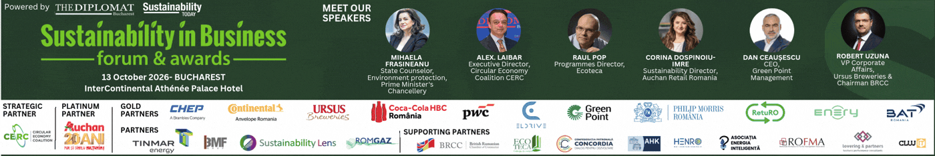

SUSTAINABILITY IN BUSINESS FORUM & AWARDS
Edition Nr. 7 | October 13 | InterContinental Athénée Palace Bucharest, Le Diplomate hall
As companies navigate increasing climate pressures, shifting regulatory frameworks, and heightened societal expectations, sustainability has become a core driver of resilience, competitiveness, and long-term value creation. The Sustainability in Business Forum provides a strategic platform for dialogue, knowledge sharing, and cross-sector cooperation, supporting the integration of ESG principles into business models and operational processes.
Throughout the event, participants will explore key themes such as decarbonization pathways, circular economy models, sustainable finance, digital transformation, and modern approaches to corporate governance. Case studies, expert insights, and sector-focused discussions will highlight both the progress achieved and the challenges that remain in transitioning toward a greener and more inclusive economy.
Recognition is extended to all speakers, partners, and attendees for their contribution to this year’s edition and for their ongoing efforts in promoting sustainability across industries. The insights and perspectives exchanged today aim to inspire stronger commitments, practical solutions, and impactful actions for businesses, communities, and the environment.

THE DIPLOMAT - BUCHAREST & SUSTAINABILITY TODAY organizes on October 13, the 7th edition of the SUSTAINABILITY IN BUSINESS FORUM, followed by the SUSTAINABILITY AWARDS GALA dedicated to recognizing the performance of initiatives, projects, companies and leaders in the Romanian economy.

The event is supported by:
STRATEGIC PARTNER: CERC – Coalition for Circular Economy
PLATINUM PARTNER: Auchan Romania
GOLD PARTNERS: CHEP, Continental Romania, Ursus Breweries, PwC Romania, ElDrive, Coca-Cola HBC, Green Point, Philip Morris, RetuRO, Enery, BAT
PARTNERS: Tinmar Energy, BMF Grup, Sustainability Lens, Romgaz
PARTNER INSTITUTIONS: German-Romanian Chamber of Commerce (AHK) Romania, British-Romanian Chamber of Commerce (BRCC), Concordia Employers’ Confederation, Ecoteca, Association of Electricity Producers – HENRO, Intelligent Energy Association,
ROFMA, ROMPAP, Cluj IT Cluster, Lovering & Partners
MEDIA PARTNERS: Outsourcing Today, Automotive Today, Financial Intelligence, Romania Durabila, Economistul, Club Economic,
Ziarul Bursa, Invest Energy

Established 7 years ago, the Business Sustainability Forum and Awards Gala annually presents the essential and fundamental elements of sustainability and ecological developments within the Sustainability Forum and rewards the performance of initiatives, projects, companies and leaders operating in intersectoral fields in Romania within the Sustainability Awards Gala.

EVENT AGENDA

13:00 – 13:30 Welcome Guests & Official Opening Address
13:30 – 15:00 SUSTAINABILITY FORUM | SESSION I
15:00 – 15:20 Coffee Break
15:20 – 16:50 SUSTAINABILITY FORUM | SESSION II
16:50 – 17:30 Networking Cocktail & Gala Dinner
17:30 – 19:00 THE SUSTAINABILITY IN BUSINESS AWARDS CEREMONY

LEADERSHIP IN SUSTAINABILITY | ACTIONS | EFFECTS | BUSINESS TRANSFORMATION
In October, we highlight the PERFORMANCE of companies, managers and initiatives in strategic industries that have stood out through effective actions in the most important aspects of the Romanian economic landscape.

SUSTAINABILITY FORUM AGENDA

13:30 – 15:00 SUSTAINABILITY FORUM – SESSION I
Governance & Compliance: ESG Integration Under Europe’s Evolving Policy Landscape

Focus: Aligning Policy, Finance, and Compliance for Sustainable Transition and ESG Accountability
Key Discussion Topics:
- National Sustainability Priorities: Policy, Investment, and Sectoral Transition Plans
- Navigating the New Sustainability Rulebook: CSRD, ESRS, and Emerging EU Obligations
- Sustainable Capital: Accessing Green Financing, Incentives, and EU Taxonomy Opportunities
- Corporate Accountability: Preparing for ESG Audits and Regulatory Scrutiny
- The AI Edge in ESG: Leveraging Artificial Intelligence for supplier data collection and reporting automation.

15:20 – 16:50 SUSTAINABILITY FORUM – SESSION II
Operational Transformation, Net-Zero Strategy and the Future of Industry

Focus: Scalable solutions for industrial efficiency and decarbonization
Key Discussion Topics:
- Decarbonizing the Value Chain (Scope 3): Collaborative frameworks with logistics and supply chain partners to reduce indirect emissions.
- Green Energy & Mobility Infrastructure: Accelerating electric fleet adoption, charging network development, and facility energy optimization.
- Industrial Best Practices: Success stories and benchmarks in low-carbon technology adoption and process modernization.
- Climate Resilience & Asset Protection: Strategies for ensuring business continuity against emerging environmental risks.
- Strategic Public-Private Partnerships: Unlocking EU and national funding to accelerate large-scale green investment projects.

SUSTAINABILITY AWARDS GALA

THE SUSTAINABILITY AWARDS GALA is dedicated to performance in developing sustainable initiatives, projects and leaders from the business sectors of the Romanian economy, to further highlight the importance of sustainable actions regardless of industry or region.

JURY BOARD of SUSTAINABILITY AWARDS GALA
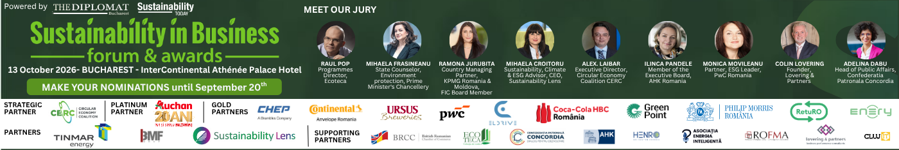

RAUL POP Programmes Director, Ecoteca
MIHAELA FRĂSINEANU State Counselor, Environment protection, Prime Minister's Chancellery
RAMONA JURUBIȚĂ Country Managing Partner, KPMG Romania, FIC Board Member
MIHAELA CROITORU Sustainability, Climate & ESG Advisor, Sustainability Lens
MONICA MOVILEANU Partner, ESG Leader, PwC Romania
ALEX LAIBĂR Executive Director, Circular Economy Coalition CERC
ILINCA PANDELE Member of the Executive Board, AHK Romania
ADELINA DABU Director of EU and International Affairs, Concordia Employers' Confederation
COLIN LOVERING Founder Lovering & Partners Business Consultants
SILVIA VLASCEANU Executive Director HENRO

AWARDS GALA CATEGORIES

COMPANY AWARDS
GAME CHANGER IN SUSTAINABILITY
SUSTAINABILITY FRONTRUNNER IN THE INDUSTRY
NET-ZERO CARBON STRATEGY
SUSTAINABILITY PARTNERSHIP
ESG INVESTOR OF THE YEAR
SUSTAINABLE FINANCE SOLUTIONS PROVIDER OF THE YEAR
SUSTAINABLE SUPPLY CHAIN OF THE YEAR
CORPORATE LEADERSHIP IN SUSTAINABILITY

PROJECT AWARDS
EDUCATIONAL PROJECT IN SUSTAINABILITY
SUSTAINABLE INNOVATION CONCEPT
SOCIAL VALUE INITIATIVE IN SUSTAINABILITY
CLIMATE ACTION PROJECT OF THE YEAR
CIRCULAR ECONOMY INNOVATION
WASTE AND RESOURCE MANAGEMENT PROJECT OF THE YEAR
TECHNOLOGY IMPACT AWARD

LEADERS AWARDS
CEO LEADERSHIP IN SUSTAINABILITY
SUSTAINABILITY LEADER OF THE YEAR
SUSTAINABILITY AMBASSADOR
PERSONALITY OF THE YEAR

Website: SUSTAINABILITY IN BUSINESS - FORUM & AWARDS - BY THE DIPLOMAT BUCHAREST

