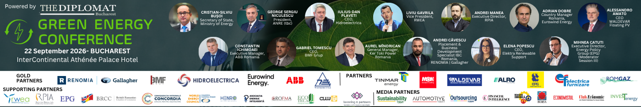

In 2026, green energy transformation enters a phase of accelerated deployment, driven by advanced technologies, reinforced climate policies, and rising consumer and corporate demand for sustainable solutions. Renewable energy sources—solar, wind, geothermal, and green hydrogen continue to expand as innovations in storage, digitalization, and smart grid integration enhance overall efficiency and reliability.

As Europe intensifies its efforts to meet the Fit for 55 targets and strengthen energy security, 2026 stands as a pivotal year for implementing large-scale renewable projects, scaling up green infrastructure, and enabling cross-sector decarbonization. This year's conference brings together policymakers, investors, technology leaders, and major energy consumers to explore the next steps toward a resilient and climate-neutral energy system.

The Diplomat-Bucharest organizes on September 22 at the InterContinental Athénée Palace Bucharest, Le Diplomate hall,
the sixth edition of the GREEN ENERGY CONFERENCE dedicated to the green updates in the energy field.

The event is supported by:
Evenimentul espre sprijinit de:
GOLD PARTNERS Renomia | Gallagher, BMF Grup, Hidroelectrica, Eurowind Energy, ABB, Transelectrica
PARTNERS Tinmar Energy, Monsson Trading, Waldevar Energy, Alro, Eximprod Grup, Electrica Furnizare, Romgaz
SUPPORTING INSTITUTIONS RWEA, RPIA, BRCC, EPG, Concordia, Asociatia Energia Inteligenta, World Energy Council, HENRO, ROFMA, Ecoteca, Cluj IT Cluster, Lovering & Partners
MEDIA PARTNERS Outsourcing Today, Automotive Today, Sustainability-Today, Financial Intelligence, Revista Economistul,
Romania Durabila, Club Economic, Ziarul BURSA, Revista Piaţa, Invest Energy

CONFERENCE AGENDA

09:00 – 09:45 Registration & Welcome Coffee
09:45 – 10:00 Official Opening
10:00 – 11:30 SESSION 1: Strategic Investments, Policies and Regulatory Frameworks for the Energy Transition
11:30 – 11:45 Coffee Break
11:45 – 13:15 SESSION 2: Technology, Digitalization and Storage – Building a Resilient and Flexible Energy System
13:15 – 13:30 Coffee Break
13:30 – 14:30 SESSION 3: The Energy Transition in Practice: Perspectives from Industry, Retail and Major Energy Consumers
14:30 – 15:30 Networking Lunch

10:00 – 11:30
🔹 SESSION 1: Strategic Investments, Policies and Regulatory Frameworks for the Energy Transition
How can public policies, regulatory frameworks, and sustainable financing models accelerate the development of green energy projects in Romania in 2026? This session examines the evolving role of government institutions, financial stakeholders, and major energy consumers in supporting national decarbonization objectives and aligning Romania’s energy transition with the European Union’s climate targets.

Key Discussion Points:
· Implementation and progress of the Repower EU and Fit for 55 objectives at national level
· Strengthening the regulatory framework to support the accelerated development of renewable energy projects
· Sustainable financing, bankability, and risk-mitigation mechanisms for green energy projects
· Risk management: Insurance and guarantee solutions to secure capital investments.

11:45 - 13:15
🔹 SESSION 2: Technology, Digitalization and Storage – Building a Resilient and Flexible Energy System
How do emerging technologies, digital platforms, and advanced storage solutions enhance grid flexibility, operational efficiency, and renewable energy integration?

Key Discussion Points:
· Smart Grids: Integration of smart grids, IoT, AI, and real-time data analytics into modern energy systems
· Advances in storage solutions: large-scale BESS batteries, green hydrogen, long-duration energy storage
· Digital Twins and Automation: Automation, digital twins, and energy efficiency in industrial operations
· Cybersecurity and digital resilience for critical energy infrastructure

13:30 - 14:30
🔹 SESSION 3: The Energy Transition in Practice: Development, Industry and Major Energy Consumers
How is the private sector implementing the green transition through on-site projects, efficiency measures, and long-term contracts?

Key Discussion Points:
· Engineering, Procurement and Construction (EPC): Real-world challenges in the development of large-scale photovoltaic and wind farms.
· Industrial prosumers: Investments in on-site renewable energy plants (on the rooftops of factories, warehouses, and stores).
· PPA (Power Purchase Agreement) Contracts: How major energy consumers secure green energy directly from developers.
· ESG Strategies in Retail and Logistics: Best practices, sustainability standards, and reducing the carbon footprint across the supply chain.

GREEN ENERGY CONFERENCE 2026 - Powered by The Diplomat Bucharest

