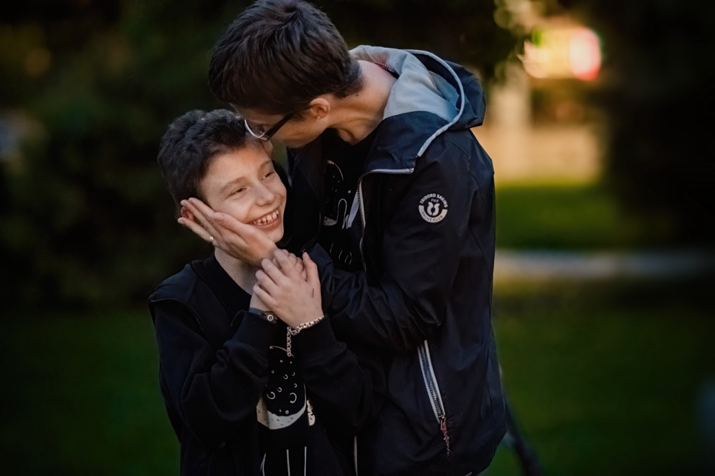

Another year to tell her “Happy Birthday!”

Ingrid has turned 9. It is truly a gift to have the chance to tell your child Happy Birthday again after a diagnosis from which in Romania patients die more than in other countries, because of the treatment conditions. Ingrid and Iuliana, her mother, left Iași for Timișoara for an additional chance of living, but they were away from their family for 10 months.

Ever since she was a little girl, Ingrid liked to spend time outdoors. Sticks, cones and leaves were her treasures. In order to discover them, her parents would strap on their rucksacks and leave on expeditions: her mom escaping from her corporate life and her father away from the kitchen he worked in. They even had a special spot of their own, at Izvorul Muntelui.

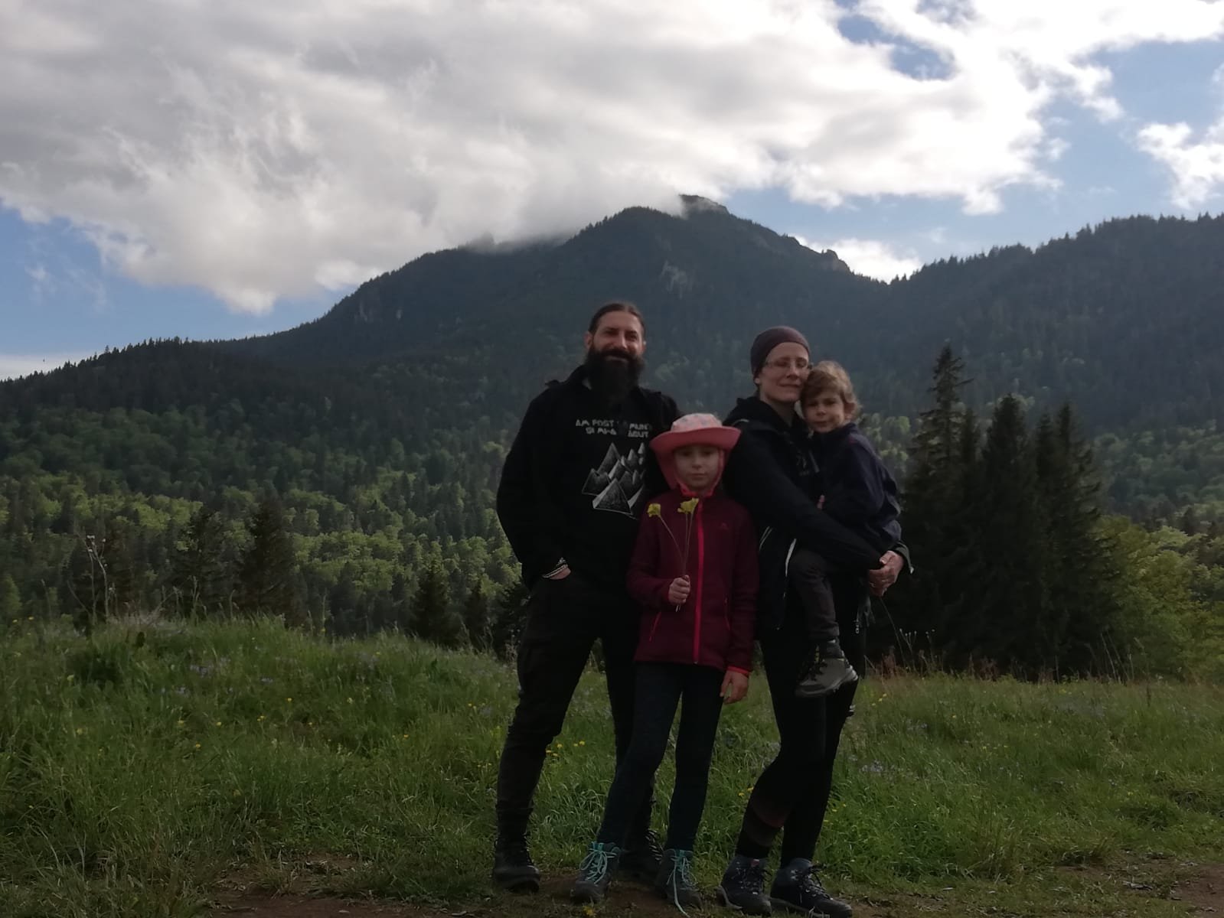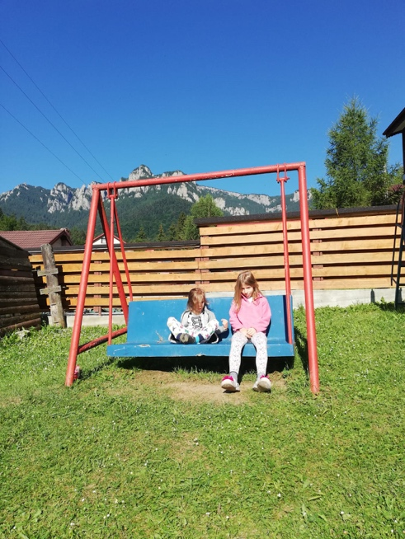
(Photos personal archive)

For this reason, it felt weird when, last summer, Ingrid, who could walk for long distances, started complaining more and more of being tired. They didn’t go to the hospital at first, but after about 3 weeks of fatigue, Ingrid started to look pale and one day she ran a fever. Her parents thought it was heatstroke after a trip to the pool, but her pallor soon changed to a brownish color, which sent them running to the St. Mary Hospital in Iași, where they lived.

After the first tests, her hemoglobin came back at 3.3 g/dl. Iuliana didn’t know what that meant. To her, 3.3 was just a number. They told her the tests didn’t look well, as the lower limit for hemoglobin values was 11 g/dl. They got transferred to intensive care for a blood transfusion and there they were told she was suspected of having leukemia. They did a spinal tap and the second day, the 5th of August 2021, they found out the diagnosis: precursor B-acute lymphoblastic leukemia.

The doctor told her there was a standard treatment in all of Europe for that type of disease, with the highest possible rate of recovery, but it was going to take time. But Iuliana was lost: “He tried to explain what that meant, but I didn’t get any of it. Someone was speaking and I could see their lips move, but I wasn’t hearing anything. It was very sad and I panicked. In that moment, you can’t find the clear-headedness to think about what to do, what treatment to… You just think… of the worst.”

***

That was the first time they got admitted to the hospital in Iași, while everyone around them was talking about the bad conditions in public hospitals and the pressure inside was rising. The staff kept telling them: “Watch out for infections , watch out for infections!” But real life was more complicated than theory.

Every ward had 3-4 beds with children and mothers who waited in line to use a bathroom they shared with another ward. Iuliana tried to watch out, but she didn’t really stand a chance. She felt that everything she touched was an infection risk, so she stocked up on disinfectants, paper toilet coverings, soap and toilet paper. She was cleaning the toilet 24/7. Iuliana would have wanted different treatment conditions not on a whim, but for sheer necessity: “When you’re in the hospital, you should be focusing on what is happening to you and how to get through it, not dodging infections and sleeping with your disinfectant bottle held tight.”

Everyone around told her that people who could afford it went abroad and wouldn’t start treatment in Romania: “Why did they all leave? Because of the hospitals.” Iuliana trusted the doctors, but not the environment. According to SIOP (the International Society for Pediatric Oncology), the survival rate of children with cancer, measured throughout 5 years, is up to 20% smaller in Eastern Europe than in the West. The difference comes from the unequal access to the best standards of medical care. Like a bathroom for every ward.

***

Iuliana tried to find a hospital where Ingrid would have more chances of living. After many phone calls, she got in touch with Dăruiește Viață and was suggested to leave for Timișoara, where the association had completely renovated the Pediatric Oncology and Hemato-Oncology Clinic within Louis Țurcanu Hospital, in case Ingrid would need a transplant. After two weeks of treatment in Iași, she waited for the test results and they left, just the two of them, not knowing for how long. Ingrid was too weak after chemo to enjoy her first time on an airplane.

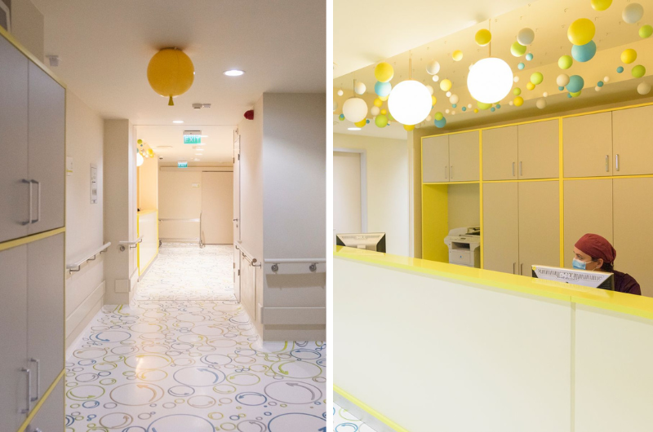

In Timișoara, the staff seemed more rigid, more severe and had clear rules. The wards had 1-2 larger beds, individual bathrooms and more space: “It means a lot to have a bathroom for each ward – a normal bathroom, where you go like a normal person and don’t come out traumatized. To have hygiene rules that are actually followed, to have a wardrobe that is nice and colorful.”

Dr. Loredana Balint Gib, Ingrid’s attending physician, says one of the secondary effects of treatment is that the body loses its capacity to fight bacteria, viruses and fungi: “For these children, it’s important that the environment be friendly and comfortable, but most of all clean. Ideally, we should have wards with 1-2 beds and individual bathrooms, to allow for an optimal isolation and decrease of infections.”

Iuliana made a good team with Dr. Balint Gib in explaining the situation to Ingrid: she talked to her as she would have done to an adult, just without saying cancer (even if other people said it), and avoided underlining the gravity of the situation. She asked the doctor all the questions in front of Ingrid, and the doctor explained everything to them in easy to understand terms, with details on the stages and secondary effects.

Ingrid responded well to the treatment right from the start, and Iuliana took this to heart: “Our strength came from Ingrid, who understood, agreed, held on, hoped and believed. And if she could enjoy a Lego, a movie or other small things even while the IV was running, then so could we.”

***

Cancer changes not only the child’s life, but the family as well. The child and, usually, the mother are taken out of their family, out of kindergarten, out of school, out of the workplace, separated from their friends and all normal activities and they spend months at a time in the hospital. Then come the treatments, procedures, surgeries, many of them traumatizing to everyone. In Romania, according to an analysis of the Ministry of Health, between 2014 and 2018, every year we’ve had 814, 786, 597, 481, and 569 new cases of cancer in children and teenagers.

It was already September. Ingrid was supposed to start school, but her desk stayed empty. She participated in online classes, took tests her mother printed and did her homework in the after school program. Teachers Laura Bârsan and Irina Bulgariu sent her textbooks and supported her in any way possible. When one or another of her classmates got COVID, she was happy to see someone else online. Iuliana used to tell her: “Don’t be glad because they’re sick!”, but Ingrid felt differently: “Yes, but now it’s not just me.” When it was just the two of them, she sat at the table, but if there was someone else in the ward she preferred to be in bed.

The rest of the time, she liked coloring and crafting. She made bookmarks for the entire department: orderlies, nurses, doctors. They were the only way of saying thanks. Iuliana never thought of offering a bribe: “You’d feel uncomfortable to even try. I was embarassed.” Ingrid played with her Lego and some days spent hours building things. Her greatest temptation was the tablet, but the doctors didn’t encourage her to spend a lot of time in front of the screen. During the pandemic, the two psychologists in the hospitals couldn’t go to the wards to visit the patients and their parents. When the playroom reopened, they could go for an hour at a time, and for the kids it was like going to Disneyland.

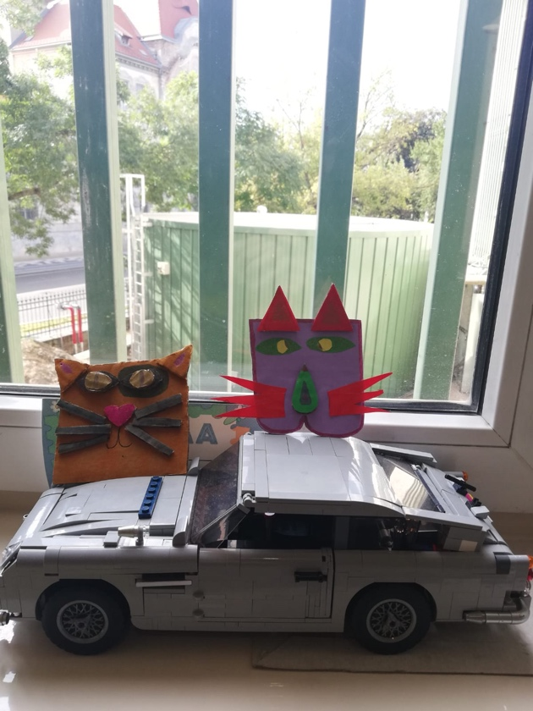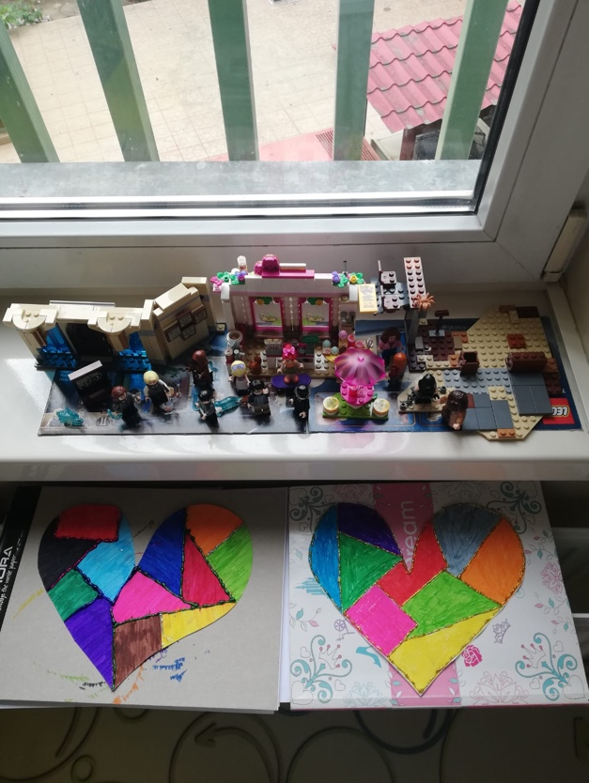

(Photos personal archive)

Iuliana’s life came to a halt alongside Ingrid’s. She had more vacation days than she would have ever wanted. She talked to a psychologist friend, she read, she did research, she took classes and became a breathwork instructor. At one point she felt tempted to work; she brought her laptop and checked her email every few days, but she realized there was no room for compromise: she couldn’t focus on that and ignore Ingrid.

***

The days went by slowly in the hospital, 668 km away from home. Ingrid woke up at 6 in the morning, had her tests, then she had trouble falling back asleep, so she’d brush her teeth and start the day. She had breakfast in bed, but she didn’t really like it. She longed for her grandparents’ cooking, but they were in Iași, helping her dad and looking after Carol, her younger brother.

The hard part were the side effects of the treament: nausea, bone pain, nervousness and agitation, a state that was reflected on Iuliana as well. When she was in pain, she asked for help; the doctor measured her pain on a scale from 1 to 10 and gave her painkillers. Ingrid got sad when her hair started falling out. A 17 year-old girl who was in for a check-up had taken a hairstyling class and gave her a haircut, but when it started falling out more, Iuliana shaved her head. Ingrid cried a lot and told her mom “You should shave your head, too!”, so her mother did just that.

The other patient in the room, a little boy who cried every time someone touched him, left after the doctors had tried everything that could be done, but the treatment had stopped working. The mother did everything she could to get to England for another chance. They got there, but soon after that, it happened. Iuliana recalls: “That was a dark day for everyone on the floor. Ingrid still doesn’t know. I didn’t know how to tell her, how to explain.”

Even during lockdown, Iuliana didn’t feel alone. She got encouragement. Her friends, colleagues and people she didn’t even know sent in presents, money and kind words. She stayed at MagicHome. In the hospital, she found the family she was missing: the children and mothers on the oncology ward. “We learned from one another, we cheered each other on, we got annoyed, but we had fun too. The Mothers’ Academy in Timișoara has monthly blood donation events for the children on the Oncology ward, they raise funds and buy drugs.”

On January 8, Ingrid turned 9. She had spent the last 5 months and 3 days in the hospital. She didn’t really talk about her feelings, but sometimes she’d say “I want to go home!” Her father and her brother visited her and celebrated her anniversary, Christmas and New Year’s Eve all in one day. A day that was different from all the others, with cake and new Lego. With tattoos, crafts and a beading set from the doctors. With the promise that “We will go home. Not right now, but we will be going there.” Iuliana tried to explain to Carol why they had left and that it would be some time before they could come back, but he didn’t seem to listen and kept changing the subject.

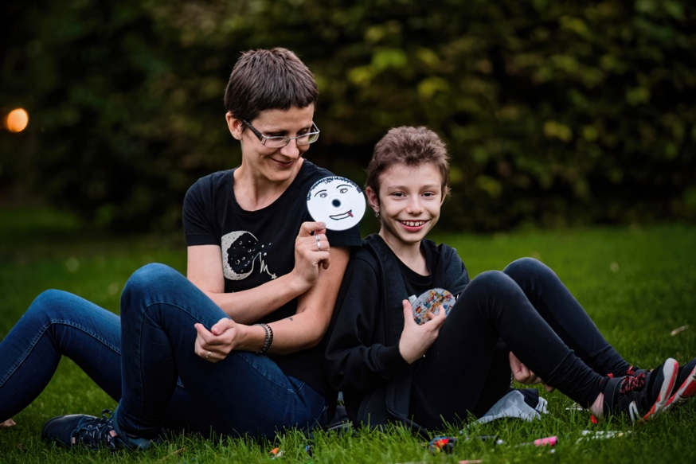

(Photo credit: Ovidiu Proca)

Iuliana did the numbers: she thought about how much money she would have spent to celebrate her daughter’s birthday if she wasn’t in the hospital and thought about the money a child in the hospital would need, even for just a few days. Then, she made a donation towards the First Children’s Hospital, built in Bucharest by Dăruiește Viață: “I wanted my present to her to be a gift for other children going through the same thing. Using everything we got for ourselves, I laid a brick at the foundation of the new hospital.” She wants #NoiFacemUnSpital, as the project is known, to have good conditions, a clean space, places for learning and for playing, psychologists, everything it needs so that parents don’t have to take their children from one city to another.

***

After finishing treatment, before being sent home, Ingrid got a clot in her heart and the doctor decided she needed a lot of tests, which took almost a month: ultrasound, MRI, then even got to the Cardiovascular Disease Institute. They had almost run out of patience with waiting. Finally, the doctors told them there was no risk.

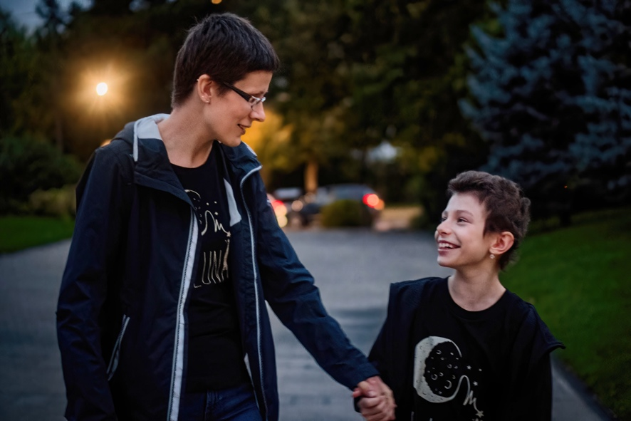

(Photo credit: Ovidiu Proca)

Iuliana took things one day at a time and left when she was supposed to. This wasn’t something she had wanted to go through: health issues or seeing Ingrid locked up in a hospital for so long, far away from her family and from the great outdoors. But it happened, so she left in search of better conditions, for a smaller risk of infection and a better chance of living. Her heart was filled with joy at the thought of going back together, on their own two feet.

They took the train from Timișoara back to Iași: a long trip, like a slow rite of passage. Her younger brother and her dad waited for them at the train station, while her grandparents waited at home. Iuliana got on with her plan to keep her getting better: “I asked my parents to come over from Roman, so that we could all be home and make her neutrophils increase faster, you know.” They got back together and they all went to Izvorul Muntelui, to start over where they had left off.

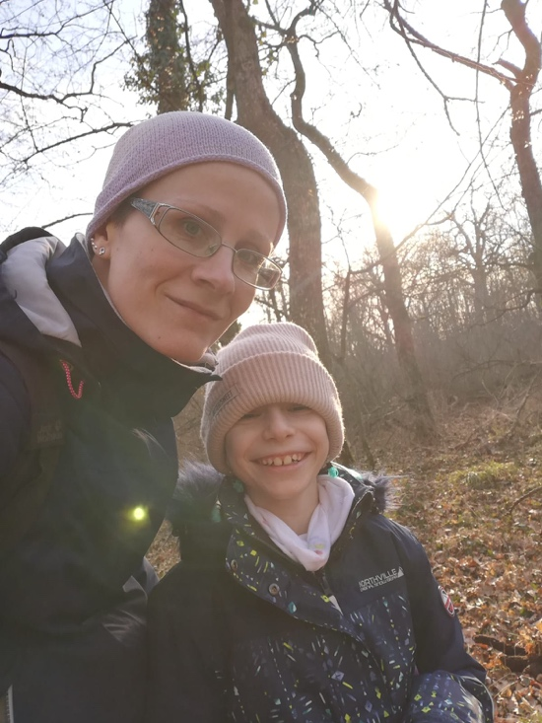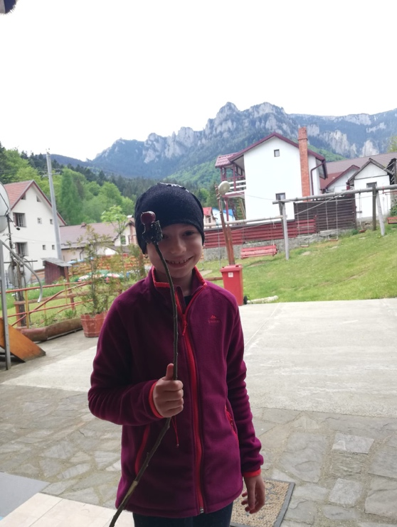

(Photos: personal archive)

It was almost the end of the school year. Ingrid only participated in the awards ceremony, where her classmates and teachers welcomed her by a round of applause. A bit uneasy with her short hair among the girls with bows in their tresses, Ingrid was excited to see her class. After her immune system got better, Iuliana surprised her and took her to a concert of om la lună, the band they had listened to in the hospital, so Ingrid got to sing and dance again.

In Romania, the challenges faced by a cancer patient and their family don’t end when they get home. Iuliana is still frustrated when she needs to be admitted to the hospital for 2 - 3 days to get medical leave and be there for Ingrid: “That’s why I understand those who choose to leave, even to leave the country, because the system is made to fight you until it gets on your last nerve.”

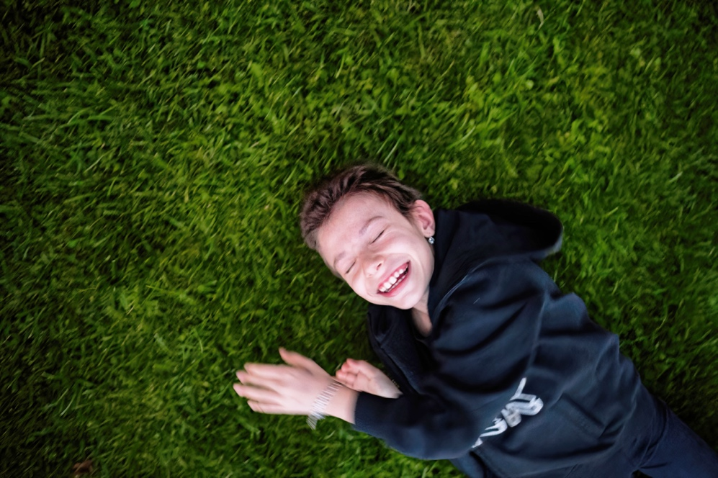

(Photo credit: Ovidiu Proca)

Ingrid is fine now. She’s enjoying the good food, walks outdoors and everything she missed during her 10 months in the hospital. She still goes to Timișoara every three months for chemo, but only temporarily, for a few days, and has to do citostatic treatment for another year. The treatment sometimes makes her feet swell and ache, but she keeps on running, even with a limp, just like any child her age. Iuliana wishes she could be there to tell her Happy Birthday every year, until she’s all grown up and healthy or until she’s too old and deaf to tell her anymore.

___

Dăruiește Viață continues to create adequate treatment conditions for the little patients, so that more and more parents can say Happy Birthday to their children. You can help us change the Romanian healthcare system too, by going to daruiesteviata.ro

___

Author: Gabriela Teodora Vătafu
Translated from Romanian by Raluca Chifu

