

Nature in a glass of wine.

Domeniul Bogdan was born from a dream...the dream of producing an exceptional and totally natural wine.

Respect for Life in all its forms is the base of our philosophy: respect for Nature, for the Earth, plants,animals, insects, the environment of the people working on the farm and, last but not least, for the people who consume our wines.

The vines cultivation is based on the biodynamic viticulture principles under the guidance of agronomist doctor in Biodynamics Leonello Anello, one of the most renowned specialists in the field.

We chose to cultivate our entire area according to the biodynamic agriculture principles – the Life forces science, this being the best way to obtain vines with a very good vitality. This method of cultivation allows terroir to express itself through the development of authentic flavors and the production of wines with personality.

Domeniul Bogdan wines, elegant, intensely fruity, totally natural, reflect our respect for Nature and the passion with which they were created.

Our grapes are certified as organic by

the Austria Bio Garantie since 2016.

(nr.cert. 2-05332-2016)



According to Agronomist Doctor Leonello Anello,

*This wine has been produced according to the scientific criteria of the modern biodynamic method, that is the application and the evolution of the impulses Rudolf Steiner handed over to farmers in 1924.*

*We worked the soil for our grapevines, we enhanced its biodiversity by sowing seeds of a thousand plants in the rows and we distributed the biodynamic preparations enabling it to receive the vital elements and make them flow into the vines. We helped vines defend themselves from parasites by using small amounts of copper and sulfur in forms that don’t penetrate the plant’s lymph and therefore they are not traceable in the wine.  
  
By facilitating the action of the natural elements in the cellar, we extracted every gift the grapes contained. We entrusted air and its light ether the task to structure and define our wine. We relied on warmth, the ether of the fire element, to elevate the expression of the grapes’ nectar from its merely physical dimension.  
  
This wine is simply a metamorphosis of the grape; it doesn’t contain added substances, even those commonly admitted by laws and regulations, and it did not undergo any physical or chemical treatment. Just a very small quantity of sulfur dioxide was added, whose total content is exactly reported on this label. Lastly we committed our wine to this siliceous glass bottle to keep it vital for long; when it meets the air that moulded it, it will live again and its qualities and complexity will increase.*  
  
***This wine are gmo free.*** *The****VINE****was nourished by the Cosmos through the Earth in which it lives.  
The****GRAPE****fermented only with its own yeasts.  
The****WINE****we give you is from one type of vine only and fully expresses its terroir.  
  
We are convinced that the way we work represents the future.****Leonello Anello***

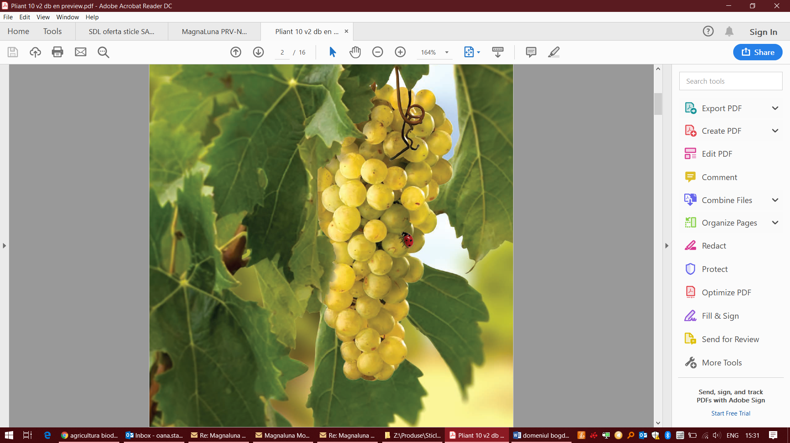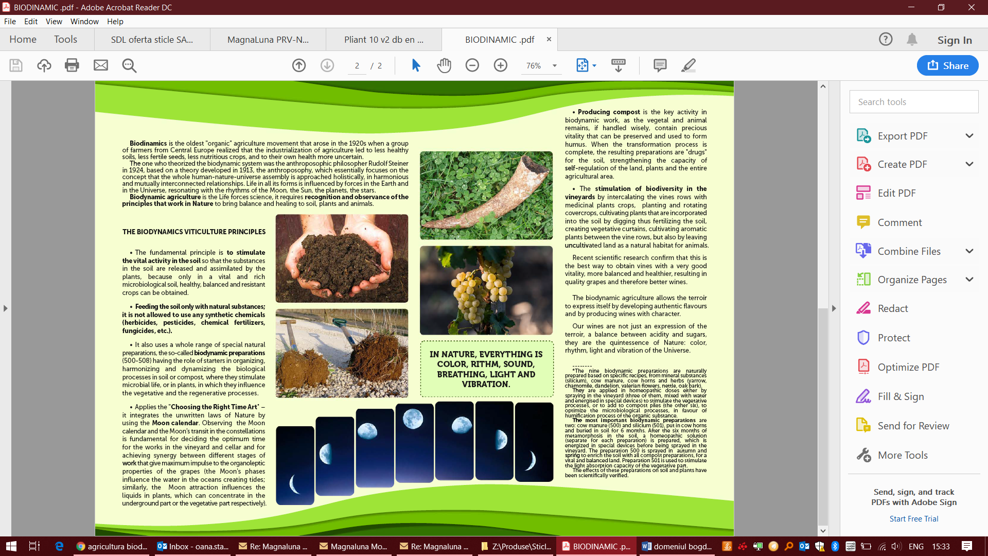

Modern Biodynamic Agriculture represents the most coherent application and evolution of the principles which Rudolf Steiner presented to farmers in the lectures he gave in Koberwitz on June 7th-17th, 1924.

We owe to a man like Rudolf Steiner and his talent for critical revision the preservation of the immense legacy of knowledge that accompanied the cultural and agricultural development of very advanced peoples of the past ages, both in the East and in the West. Rudolf Steiner was neither an agronomist nor a farmer. His aim was to lay the foundations for the development of the agriculture of the future, not in a dogmatic way, but through constant investigation: experimenting, verifying and translating the results into numbers and tables clear enough to be divulgated and used by everyone.  
  
After Steiner's death, in Europe, Biodynamics underwent a process of intellectualization that emphasized its esoteric drift. In Italy, too, biodynamic agriculture was not able to assert its authority, overwhelmed by religious-philosophical tasks that by-passed and ignored agricultural practice. Modern Biodynamic Agriculture intends to identify and spread a working method, which can be applied without ambiguity, where man, once he has regained his integrity - without any need to separate the spiritual from the physical dimension - can freely grasp an understanding of nature and how it can be applied in agriculture.  
  
Modern Biodynamic Agriculture is free from the limitations of materialistic science, yet it has to come to terms with it, and it is secular, since it does not need to find a final justification in any principle beyond itself. For this "parallel" science, which has its own vocabulary, we propose a new language which can clearly and efficiently transmit its principles that, far from depending for their interpretation on a few gurus, will enable Modern Biodynamics to become the agriculture of the XXI century.  
  
This method provides an ethical practice of agricultural production which is:

The label of biodynamic wine is not a commercial brand, but it is a seal of quality which attests the efficacy of a working method (the Modern Biodynamic Method), defined and improved along the years, and the absolute excellence of the results obtained by its application in the vineyards and in the cellar.  
  
  
Biodynamic label will distinguish those wines which, for their organoleptic qualities and through laboratory analysis, will be recognized, year by year, as absolutely excellent. These wines present unique and unmistakable characteristics and fully express their territories, with nuances and accents capable to surprise and open new perspectives on sensorial approach and wine knowledge to connoisseurs and lovers.