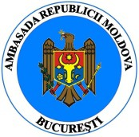
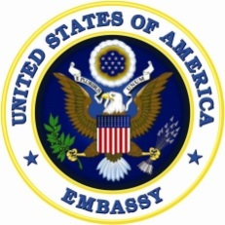
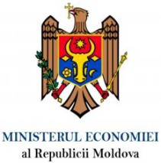
AGENDA
BUSINESS OPPORTUNITIES IN THE REPUBLIC OF MOLDOVA
FOR AMERICAN BUSINESSES IN ROMANIA

Athénée Palace Hilton Hotel Bucharest, February 21, 2017

6:30 – 7:00 p.m. | Registration of participants
7:00 – 7:05 p.m.  7:05 – 7:10 p.m. | Welcome message  Ms. Anca Harasim, Executive Director, AmCham Romania  Greeting remarks  H.E. Mr. Hans Klemm, Ambassador of the United States of America to Romania
7:10 – 7:15 p.m.  7:15 – 7:35 p.m. | Greeting remarks  H.E. Mr. Mihai Gribincea, Ambassador of the Republic of Moldova to Romania  Greeting remarks & Presentation of the Republic of Moldova’s economic devlopment opportunities: challenges and perspectives.  H.E. Mr. Octavian Calmȋc, Deputy Prime Minister & Minister of Economy of the Republic of Moldova
7:35 – 7:45 p.m. | Presentation of "Moldova – Advantages and Risks of a Foreign Investment".  Mr. Markus Piuk, Partner, Schoenherr; Mr. Vladimir Iurkovski, Head of the Schoenherr Chișinău Office
7:45 – 7:55 p.m.  7:55 – 8:05 p.m. | Presentation of the convergence of the business environment in Romania and the Republic of Moldova  Mr. Mamas Koutsoyiannis – CEO, Moore Stephens KSC Romania & Republic of Moldova  Presentation of the market potential for dried fruits and fruit distillates in the Republic of Moldova  Mr. Dumitru Vicol, General Director, MONICOL SRL
8:05 – 8:30 p.m. | Questions and Answers
8:30 p.m. | Cocktail, Networking & Tasting of Moldovan products from CRICOVA Winery

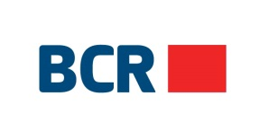
Event is organized with the support of:

