IGNITE LOGISTIC
S.C. IGNITELOGISTICS.R.L
COLINEI 8A, SIBIU

2/8/2016
WHAT OTHERS CAN’T DO WE CAN!
COMPANY PRESENTATION

GENERAL INFO
Name: S.C. IGNITE LOGISTIC S.R.L.
Address: str. Colinei, nr.8A, cod postal 550145, SIBIU, jud. SIBIU
The legal form of incorporation: S.C, IGNITE LOGITIC S.R.L. is a Romanian company, having the legal form of a limited liability company.
- National Trade Register Office: J 32/6/2014
- Fiscal code: RO32632862
Field: The main field of activity for IGNITE LOGISTIC LLC is Road Transport of Freight and Goods Movement Services, NACE 494, main activity is Freight Transport, NACE 4941. IGNITE LOGISTIC LLC also undertakes transport related activities such as maintenance and repairing vehicles from its fleet.
HISTORY
IGNITE LOGISTIC is a young company freshly appeared on the local and areal freight transport service providers market. Our company is based on an over 5 years experience in the transportation field, even though as it can be observed, it is relatively new registered at the Trade Register, it’s founding year is 2014.
From the start we wanted to become a strong company among the local, national and even international leaders in the field of freight transport.
IGNITE LOGISTICS Ignite began operations with a carrying capacity of small-scale, but the quality and seriousness in approaching the contractual commitments for our customers, have brought us the capital of trust which we commend for new collaborations.
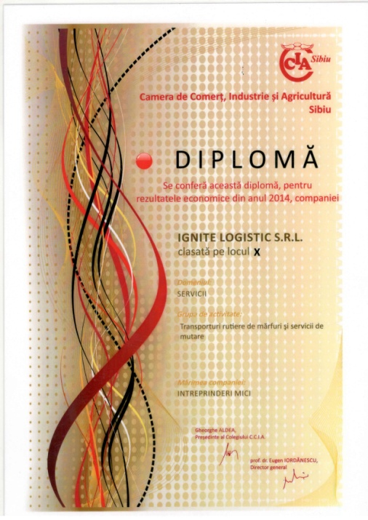

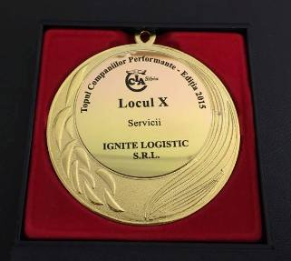

The quality and promptitude of our services placed us on the 10th place in the Efficient Companies Top – 2015 edition, top issued by the Chamber of Commerce and Industry Sibiu.
The ability of our company to addapt rapidly to our clients continuously changing requirements offered us the opportunity to contract more complexe services for our main clients. We made available for our clients a wide range of vehicles, suited both as endowment and capacity needed, to be able to satisfy the requests comming from them to a more professional level.
Currently in our portofolio can be found: DHL, Urgent Cargus, Dragon Star Courier, Brand Circus.
This was possible given that the company's management understood from the outset that one of the key elements of a functional company is adaptability and the ability to offer their clients a fleet that guarantees a permanent compliance of their requirements.
Currently we offer our clients a 50 vehicles fleet, trucks and trailers, equipped with GPS for tracking and positioning them in real time. To support our continuous activity, our company benefits from technical assistance around the clock, supported by a team of professional mechanics and the latest technology.
The number of IGNITE LOGISTIC employees has grown substantially since its foundation. IGNITE LOGISTIC began its activity with a number of 5 employees and reached currently a number of more than 70 employees.
IGNITE LOGISTIC is committed to offering quality, professionalism and competitive prices. The company will continue to grow and adapt to meet current and future needs, including the provision of services that match our customers’ requests and to be available everywhere in the country and especially outside. "What others can’t do we can" Everyone at IGNITE LOGISTICS shall strive to offer its customers the services they need including those that others cannot offer.

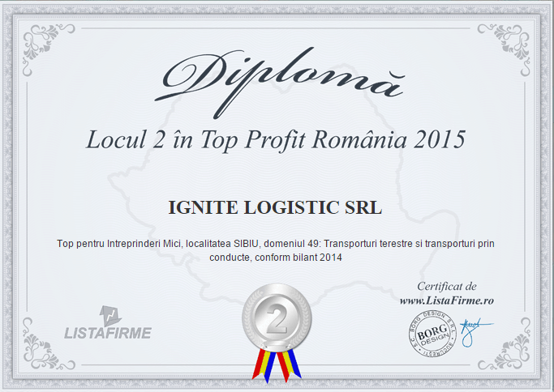
According to www.listafirme.ro IGNITE LOGISTIC ranks 2nd in the 2015 Top Profit Romania

STRUCTURA ORGANIZATORICA

IGNITE LOGISTIC is a a limited liability company entirely Romanian owned.
The IGNITE LOGISTIC shareholders are Deac Remus, Isaila Alin and Stroia Ciprian. The CEO of the company is Mr. Deac Remus, the administrator of the company is Mr. Isaila Alin and the logistics director is Mr. Stroia Ciprian. Those 3 form the management department of the company.
The organizational structure with the subordination relations emerging are presented below.

general meeting of shareholders
ceo
logistics director
LEGAL DEP.
2
ASISTENT MANAGER
finances accounting dep.
-OUTSOURCED-
SECURITY
transport
DEP.

DRIVERS62
transport
TEHNICIAN
1

tRANSPORT ACTIVITY COORDINATOR

MECHANIC2

HS DEP.
-OUTSOURCED-

IGNITE LOGISTICS management team is young, open minded, oriented towards success and development. The members of the management team are enthusiastic and have a positive attitude, they have created and imposed certain standards regarding ethical behavior which they as well as the other members of the IGNITE LOGISTIC team comply.
If at the end of 2014 the company had an average number of 17 employees at the end of 2015 this number tripled to more than 70 people, which means a 200% increase in the number of employees.

Out of the whole number of 73 employees the management team represents a percent of 3%, the technical staff being 97% out of the IGNITE LOGISTIC employees. The technical staff ensures a smooth running of the activity. The growing number of employees helps us to always be promptly available for our clients and with quality service.
Drivers are legally professionally certified by the Romanian Road Authority for national and international freight transport, some of them made advanced schooling for the transport of dangerous goods (ADR).
Transportation Activities Coordinator is also prepared to be able to coordinate and follow on the route this kind of transport.
Financial and accounting services are outsourced, performed by SC ES Consulting SRL. Also monthly health and safety is achieved through outsourced service by SC ADRIA PREST SRL.

TECHNICAL RESOURCES
IGNITE LOGISTIC holds presently a fleet of over 50 vehicles of different tonnages. All the vehicles meet the European pollution directives of EEC.
Transports made by IGNITE LOGISTIC are followed by the coordinating staff through the GPS system, satellite tracking that allows tracking of the vehicle and checking of the operating parameters during the drive. This system follows strictly the real time consumption of fuel and is a protection in case of robbery or theft.
We adapted our trucks also according to the requests received from our clients. Most of our trucks have lifts and those who do not have one have doors with safety systems.
Vehicle brands present currently in our fleet are: Mercedes-Benz, MAN, DAF, Volvo and Renault. The vehicles have different tonnages as follows
- 3.5 t – Mercedes Sprinter si Volkswagen Crafter
- 7.5 t – Mercedes si MAN
- 12 t – MAN
- 18 t – Mercedes
- 40 t – MAN TGA
- Lorry – DAF, Mercedes, Volvo si Renault
- Trailers – Schmitz, Koegel si Krone

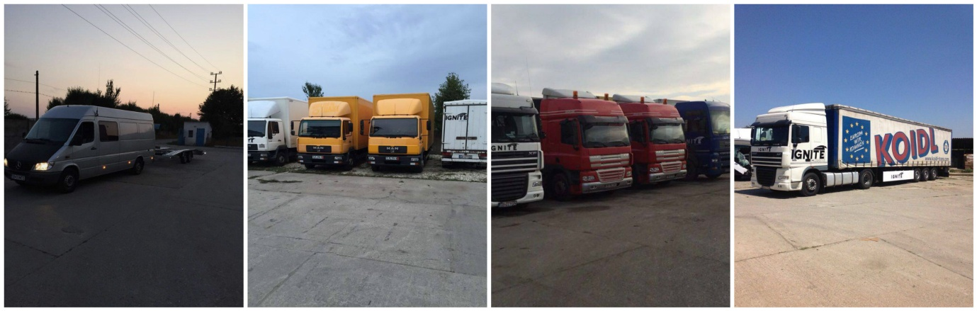

Just like the number of employees grew, during 2015 the company doubled the number of vehicles, trough acquisition of greater capacity vehicles both to the prompt requests and orders coming from our customers and to develop the company as well as to attract new potential customers.
IGNITE LOGISTIC plans to increase the fleet in 2016 also because this year our trucks will perform external routes in the E.U. area.
Our trucks and trailers are repaired in our own garage, by professional mechanics. Technical assistance is available 24/7 regardless of the place where the vehicle that needs repairing or maintenance is.

The company's headquarters is in Sibiu at Colinei No.8 and the working point, offices, garage and warehouse service are located in Ocna Sibiu.

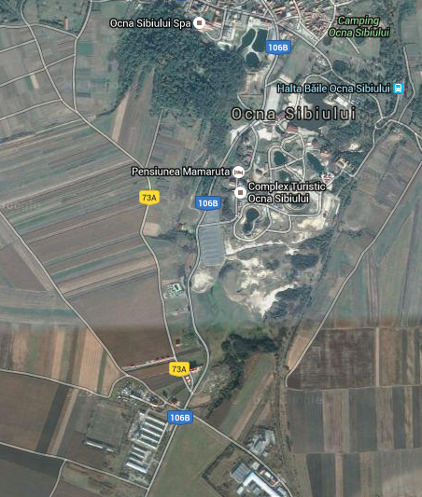
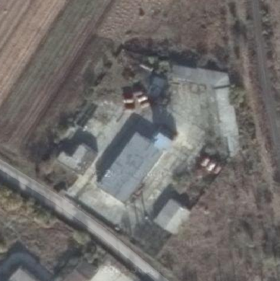

ANALYSIS AND SWOT
Given the balance sheet at the end of 2014 a brief financial analysis was obtained from Risco Financial Services SRL. Below you can see some extracts from this analysis.

Financial rating level is very good 8.5 out of 10.
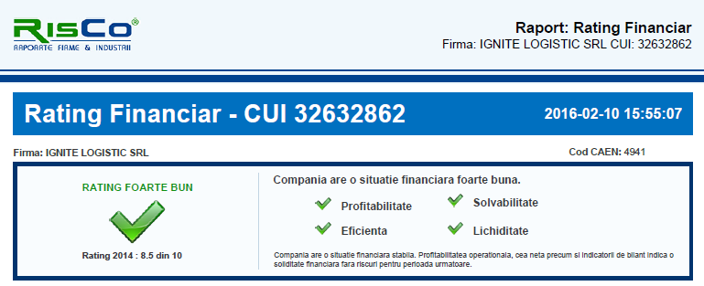
Compared to the average of the transport market, according to NACE 4941, Ignite LOGISTICS stands at an above average level at different points analyzed.
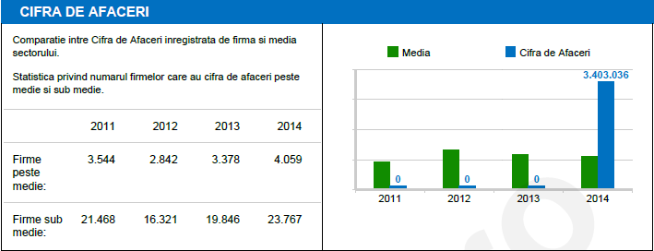
TURNOVER
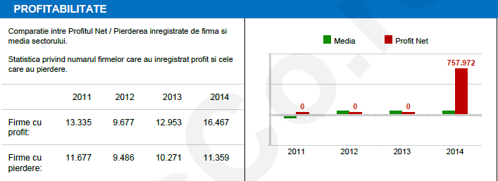
PROFITABILITY
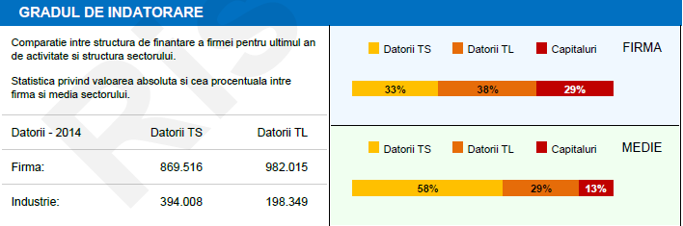
DEBT AMOUNT

SWOT
STRENGHTS | WEAKNESES
We are a growing company with young open-minded management but with experience in the field of transport  We offer our clients professionalism and competitive prices  We are a profitable, efficient with a stable financial situation  We are above the average of companies working in our field | We are a relatively new company founded on the transport market  There are companies on the market with a much larger logistic base than ours at the moment  We must cover external transport segment  No benefit of capital of trust that some of the older companies on the market have
OPPORTUNITIES | THREATS
Giving the fact that this year we started performing external transport in the E.U. represents for us a capital of trust, it shows that we can expand in the direction that we wanted right from the beginning.  Honoring professionally and promptly our current and future collaborations are also points that we follow to create quality and long term relationships with our customers | Increased fuel prices are one of the main issues that could affect the rhythm of development of our company that we tried to impose  Competition on the transport market is also one of the threats that may arise in the development of our company

